**FARMERS KNOWLEDGE BASE**

FARMERS KNOWLEDGE-BASED SYSTEM

BY

VICTOR KIPKIRUI BETT

REG NO: N11/3/0452/017

JOSEPH MWANGI

REG NO: N11/3/0460/017

ALLAN OLUOCH

REG NO: N11/3/0472/017

KIBET FRANKLINE MUTAI

REG NO: N11/3/0466/017

WARREN NDOMBI

REG NO: N11/3/068/016

SUBMITTED TO:

SUPERVISOR/INSTRUCTOR: DR. KIRORI MINDO

DEPARTMENT OF COMPUTING AND INFORMATICS

A RESEARCH PROJECT SUBMITTED IN PARTIAL FULFILLMENT OF REQUIREMENT FOR A WORLD OF BACHELOR OF SCIENCE IN COMPUTER SCIENCE OF LAIKIPIA UNIVERSITY.

# **DECLARATION:**

# WE AS GROUP P DECLARE THAT THIS IS OUR ORIGINAL PROJECT AND HAVE NEVER BEEN PRESENTED ANYWHERE FOR DEGREE OR ANY OTHER PROGRAMME.

NAME………………………. REGISTRATION NO:

SIGN………………………… DATE: …………………..

NAME………………………. REGISTRATION NO:

SIGN………………………… DATE: …………………..

NAME………………………. REGISTRATION NO:

SIGN………………………… DATE: …………………..

NAME………………………. REGISTRATION NO:

SIGN………………………… DATE: …………………..

NAME………………………. REGISTRATION NO:

SIGN………………………… DATE: …………………..

THIS PROJECT HAS BEEN SUBMITTED FOR EXAMINATION WITH THE APPROVAL OF MY SUPERVISOR

NAME………………….

SIGN……………………

DATE…………………...

**Recommendation**

We recommend this project to the stakeholders concerned to consider implementing it to help farmers to improve their farming techniques, hence enhancing their productivity.

**Copyright**

This project is the property of group p of Laikipia University students Computer Science year three.

**DEDICATION:**

WE DEDICATE THIS PROJECT TO OUR PARENTS WHO HAVE TIRELESSLY SUPPORTED US ALL THROUGHOUT OUR EDUCATION JOURNEY.WE ALSO DEDICATE IT TO ALL INSTRUCTORS WHO HAVE ENABLED US WITH THE KNOWLEDGE TO COMPLETE THIS PROJECT AND OTHER STAFF MEMBERS IN LAIKIPIA UNIVERSITY ESPECIALLY THOSE IN COMPUTING AND INFORMATICS DEPERTMENT.

# **ACKNOWLEDGEMENT:**

WE WOULD LIKE TO THANK THE ALMIGHTY GOD FOR THE GIFT OF LIFE AND PROTECTION THROUGH THE WHOLE COURSE. WE WOULD ALSO LIKE TO THANK OUR INSTUCTOR; DR KIRORI MINDO FOR SUPPORT THROUGH GROUP PROJECT. SPECIAL THANKS TO OUR C.O.D MR. NYAKUNDI.

**ABSTRACT**

Agriculture is the backbone of Kenya’s economy. Farmers needs information and skillset for a successful and profitable production. There is also a great need to create a reliable market for farm products which can create an opportunity and channel for farmers dispose their products on time and at a favorable price. Also coming up with a decision support website for farmers is a significant achievement to help farmers make relevant decision on how to run their farm.

Bringing farmers and buyers together via a website creates a market base where farmers and buyers needs can be catered for. Buyers at affordable price and at the time of need can request goods from the website. Farmers can upload their sell commodity and the interested buyers will request for the goods.

At the Farmers Knowledge Base, the agricultural offices will have a platform to educate farmers. Farmers can learn from the site thus evading the stress of travelling or attending agricultural seminars in search of information. When faced with a situation to make a choice on farming issue, Farmers Knowledge Base will help them to make an information-backed decision by putting into consideration different factor that affect agriculture.

**TABLE OF CONTENT**

**CHAPTER ONE**

**1.0 Introduction………………………………………………………………………1**

**1.1 Background……………………………………………………………………. 2**

**1.2 Statement of problem……………………………………………………. 3**

**1.3 Objectives…..…………………………………………………………………. 4**

**1.4.0 Significance of project…………………………………………………. 5**

**1.4.1 Justification…………..……………………………………………………. 6**

**CHAPTER TWO**

**2.0 Literature Review………………………………………………………….. 7**

**CHAPTER THREE**

**3.0 Methodology…………………………………………………………………. 9**

**3.1 Technology……………………………………………………………..…….10**

**3.2Hardware……………………………………………………………………….11**

**3.3 Software……………………………………………………………………….12**

**CHAPTER FOUR**

**4.0 Project………………………………………………………………………..13**

**CHAPTER FIVE**

**5.0 Conclusion……………………………………………………………………27**

**5.1 Recommendation…………………………………………………………28**

**5.2 References……………………………………………………………………29**

**5.3 Appendices……………………………………………………………………30**

**CHAPTER ONE**

**INTRODUCTION**

Agriculture is the backbone of Kenya’s economy. Though there are many efforts put in-place to aid and enhance productivity in agricultural field, still there remains a lot to be done. By use of existing technology much can be achieved. All the questions asked and faced by farmers can be answered via a knowledge-based system that can help farmer acquire various information and making decision.

Farmers’ information needs and skillset for a successful and profitable production can be taught via the websites and various technologies. There is also a great need to create a reliable market for farm products which can create an opportunity and channel for farmers dispose their products on time and at a favorable price. Also coming up with a decision support website for farmers is a significant achievement to help farmers make relevant decision on how to run their farm.

Bringing farmers and buyers together via a website creates a market base where farmers and buyers needs can be catered for. Buyers at affordable price and at the time of need can request goods from the website. Farmers can upload their sell commodity and the interested buyers will request for the goods.

At the Farmers Knowledge Base, the agricultural offices will have a platform to educate farmers. Farmers can learn from the site thus evading the stress of travelling or attending agricultural seminars in search of information. When faced with a situation to make a choice on farming issue, Farmers Knowledge Base will help them to make an information-backed decision by putting into consideration different factor that affect agriculture.

**1.1 BACKGROUND**

Kenya being an agriculture dependent nation, there is a great need to support and educate farmers to enhance their production level. It is a great challenge for farmers to gather information on how to plant, grow and store their products, also there is a need to create more market for farmers and also for interested buyers who needs agricultural products and inputs from farmers. We believe by coming up with a **FARMERS KNOWLEDGE BASE** will aid farmers to make more relevant decisions, much effectively and also get information to grow specific crops or how to handle the raring of livestock and poultry.

**1.2 STATEMENT OF PROBLEM**

Educating farmers on how to grow various crops and rare different domestic animals is a necessity action that ought to be undertaken in order to enhance agricultural productivity. This leads to a need to create a reliable marketing base for farmers to make their efforts in the farm rewarded.

There is a problem when it comes to farmers in Kenya yet agriculture is the backbone of our country’s economy. The main problems faced by farmers are: lack of proper information on how to cultivate various crops and marketing them, also most farmers lack knowledge on proper raring of farm animals.

In our project we propose to develop Farmers Knowledge Base that will solve these problems encountered by farmers. The system will allow the farmers to get information on the best farming methods, market their products and also allow buyers to access farm products easily. It will also give the agricultural officers an opportunity to create awareness to the farmers on the latest farming methods and best farm inputs to use.

**1.3 OBJECTIVES**

1. Helping farmers to make decisions backed by information and knowledge by coming up with a knowledge base system that puts into account different factors that affect agriculture. The system which can combine numbered facts to come up with an inference will help farmers make decision.
2. To help farmers enhance their agricultural productivity by helping them acquire knowledge and guidance on how to grow crops and rare various domestic animals.
3. Helping farmers to market their goods. Creating a platform that links buyers and farmers will create a market opportunity that can be utilized by farmers.
4. Creating a platform that can bring farmers together thus creating a channel for agricultural officers to disseminate their information to farmers.
5. Brokers have been a nuisance to farmers and buyers by over exploiting them. Therefore linking farmers and buyers – to eradicate brokers – is our objective.

**1.4.0 SIGNIFICANCE OF THE PROJECT**

Lack of information to new farmers or inadequate information to the existing farmers is a drawback to agricultural sector in many Kenyan regions. Thus it is more significant to create a **Knowledge Base** to complement the existing information on agriculture.

Inadequate market to buy farm inputs or to sell agricultural goods is a challenge to farmers. Thus it is important to link interested potential buyers to farmers seeking market for their goods.

Agricultural specialists who have knowledge on agricultural practices may need to educate farmers more efficiently, coming up an application whose main users are farmers can create a platform where agricultural officers can disseminate their knowledge to farmers

**1.4.1** **JUSTIFICATION OF PROJECT**

There being a need to provide information and guidance to farmers putting into consideration the difference in locality of farmers, it is good to build an application that meets these specifications and user needs.

Because farmers need to get more reliable market to sustain the existing market opportunities, creating a system to link buyers and farmers is a wise and advisable activity to undertake.

To help the agricultural officers to disperse their knowledge to farmers, building a platform to bring farmers together likewise creates a platform to enable these agricultural officers to disperse their knowledge.

**CHAPTER TWO**

**LITERATURE REVIEW**

Farming has been and still is a crucial sector of Kenya’s economy. Agriculture creates employment opportunity to a larger portion of Kenyan population. Although this being the case, agriculture faces a mass of challenges such as poor market, low prices for farm products leading to loses to farmers, problem of market availability and also the unpredictable nature of the weather condition. Above all these challenges, farmers also find themselves in a challenge of making decision about their farms for they much often find themselves not well versed with information on growing different plants.

There are lots of efforts made to help farmers to achieve. Many e-commerce applications have been created thought they have not addressed the market situations of the agricultural products. Brokers have found an opportunity to exploit farmers in the name of providing market to farmers. Buyers who are in need of agricultural products are left hunting for goods each and after every other day yet farmers are on the other side of tunnel longing for somewhere to dispose their products.

There are also firms and organizations created by government and different people which are working very hard to educate farmers. This is an option to the farmers but these farms are scattered in different locations in Kenya and also their information is narrowed to a narrow and specific domain of expertise. This makes it worthy to come up with a platform to unite different agricultural experts to create a reliable channel for farmers to get information from.

The Farmers Knowledge Base acts as a platform to address much if not all the challenges that are being faced by and limiting farmers significantly. The platform brings farmers, buyers and agricultural officers together. Farmers can give out their goods for sell at the Farmers Knowledge Base. Then the interested buyers can find and choose their specific goods sold by the farmers without the intervention of the brokers. In addition, business people dealing with farm inputs, chemicals and animal feeds also have an opportunity created for them to utilize because they can market their goods to farmers.

The interaction point created by Farmers knowledge Base by bringing farmers and agricultural officers together poses an opportunity for both parties. The farmers can get the information from the experts thereby bringing the dream of agricultural officers to disseminate their knowledge to farmer to reality. The agricultural officers can help farmers to uplift their dairy farm crops and animal handling and caring by creating awareness and offering farmers with different skillset via Farmers Knowledge Base.

Decision making moments can be a brainstorming moment to farmers who are trying to figure out what to plant, how to plant it and what they need to make it a success in their agricultural occupations. Farmers Knowledge Base have a simple decision-making functionality to help farmers to come up with prudent decision. Farmers Knowledge Base considers the climatic conditions, altitude and also the best crop grown in a given region and thereafter give a farmer recommendation of what to plant. The application therefore can help the farmers to make decision putting the aforementioned factors into consideration.

**CHAPTER THREE**

**3.0 METHODOLOGY**

After doing our research we found out that most farmers and people in Kenya have access to the internet via their smartphones. Therefore, we decides to create a web based system for farmers to access when they want to learn something on agriculture or if they want to market their produce to the people.

**3.1** **TECHNOLOGY**

We used the following technologies to achieve our project: HTML for the front end of the project. We also used PHP for backend scripting. To validate users input we used JavaScript and CSS for styling the interfaces.

**3.2** **HARDWARE**

We used Computers (lap top) as the only hardware in the project designing process.

**3.3** **SOFTWARE**

We used the following set of software in the realization of the project. We used Visual Studio Code as the main coding platform. We also used Wamp Server as the localhost server and Google Chrome browser in running the project.

**CHAPTER FOUR**

**4.0 ACTUAL PROJECT**

**4.1 IMAGES**

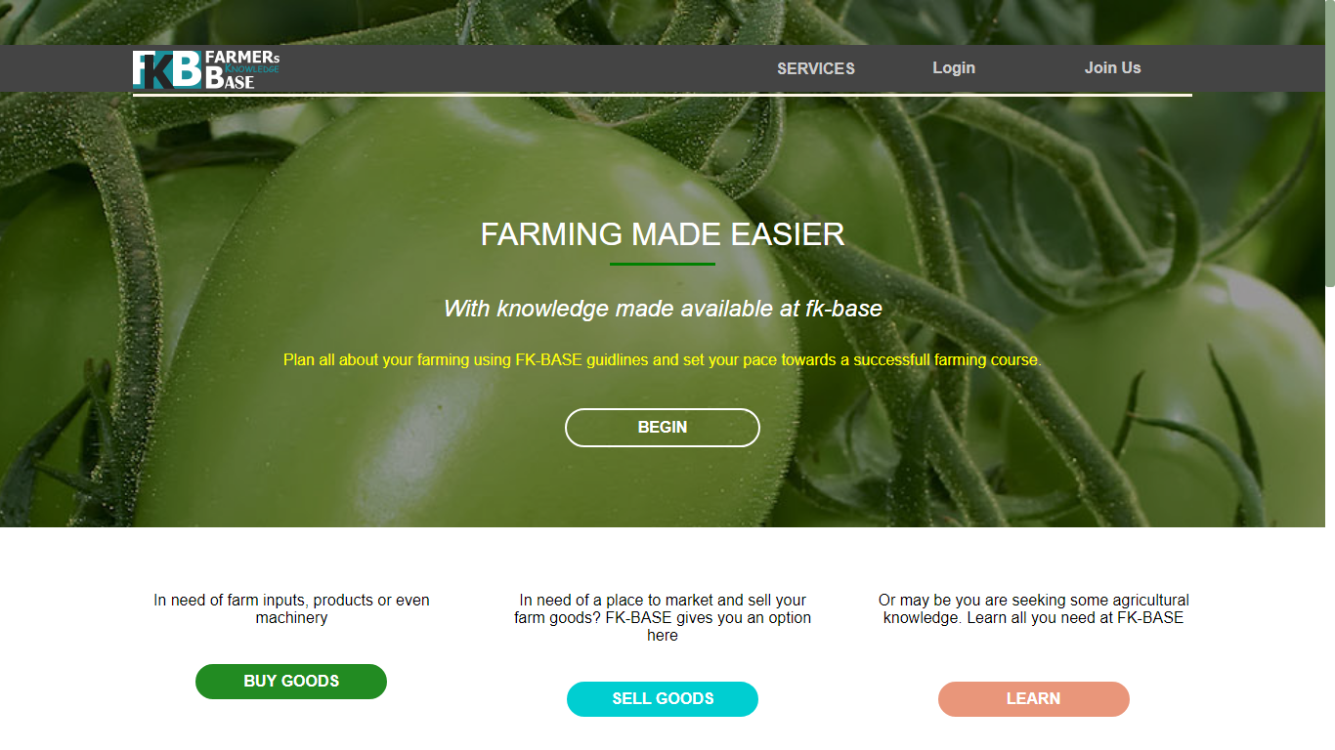

Fig1. Home page of Farmers Knowledge Base

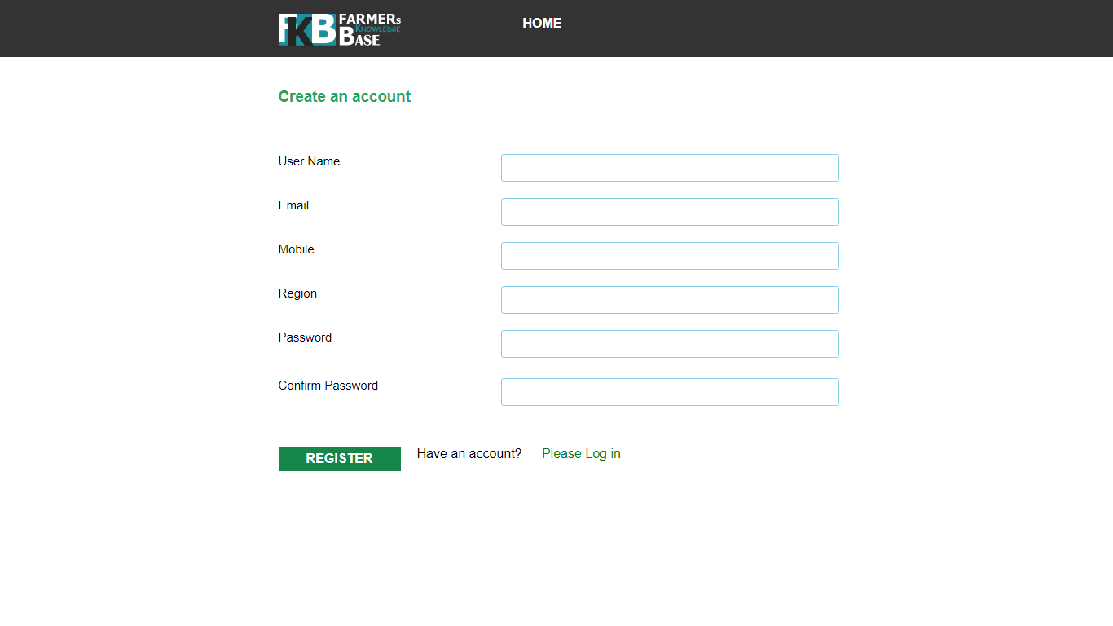

Fig2. Create account page

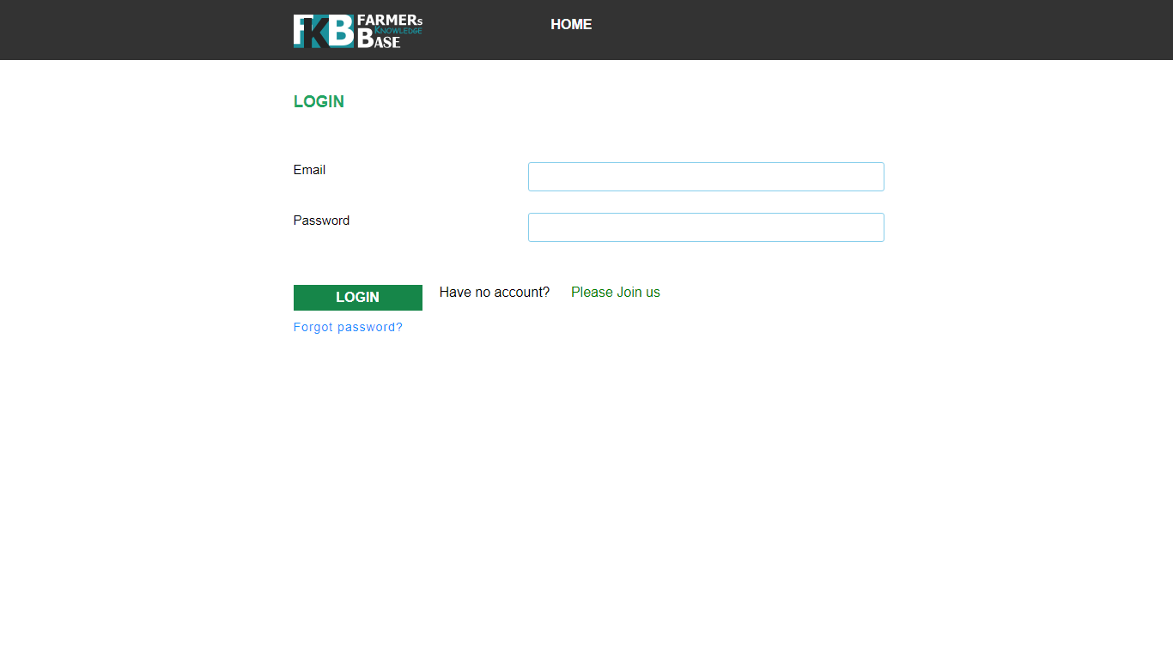

Fig3. Login Page

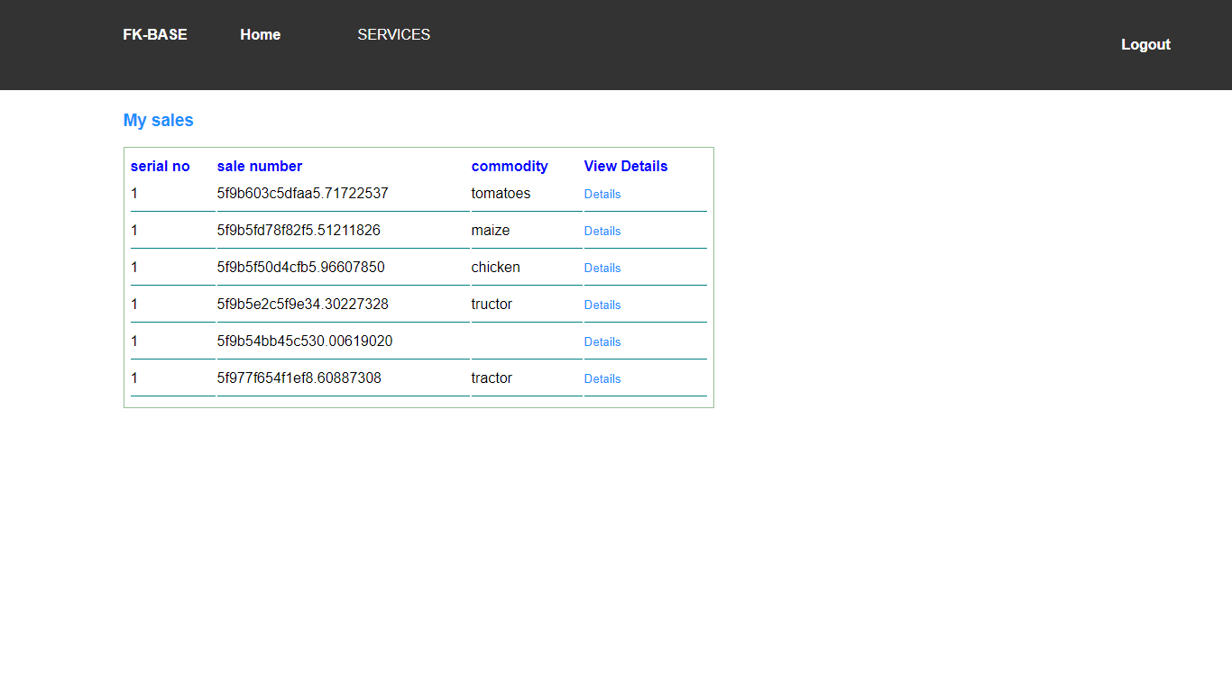

Fig5. User’s sales pages

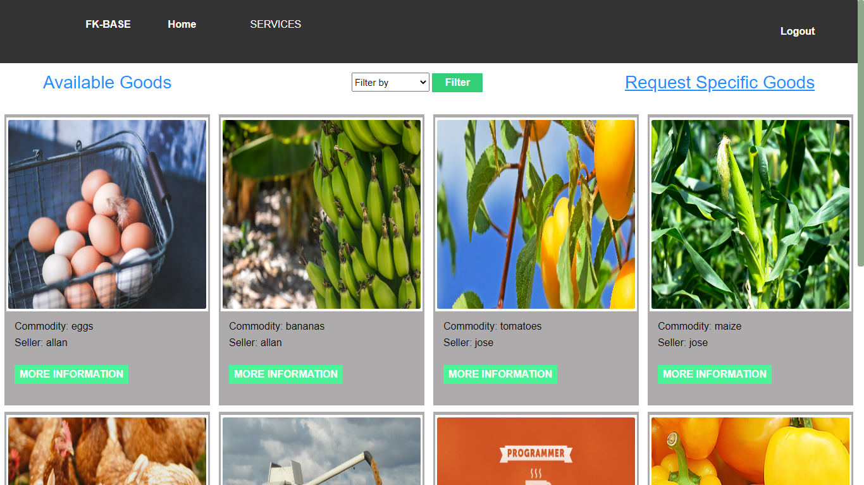

Fig4. Buy Goods page

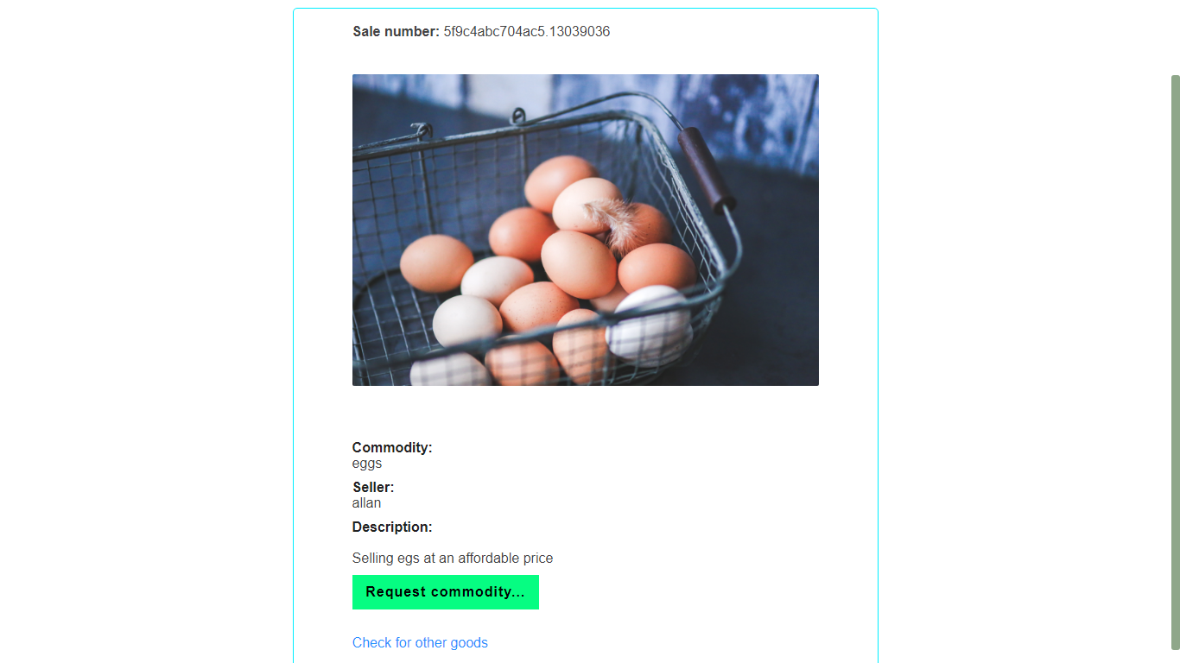

Fig6. Request a commodity page

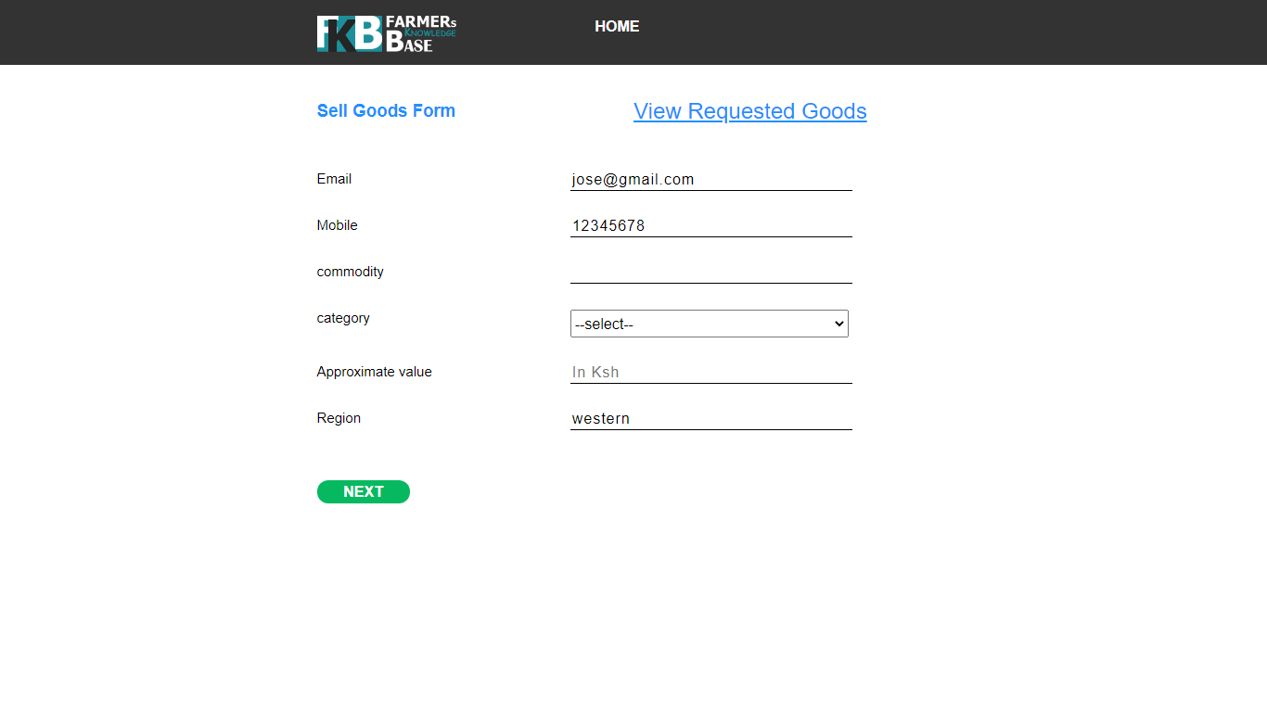

Fig7. Sell goods form

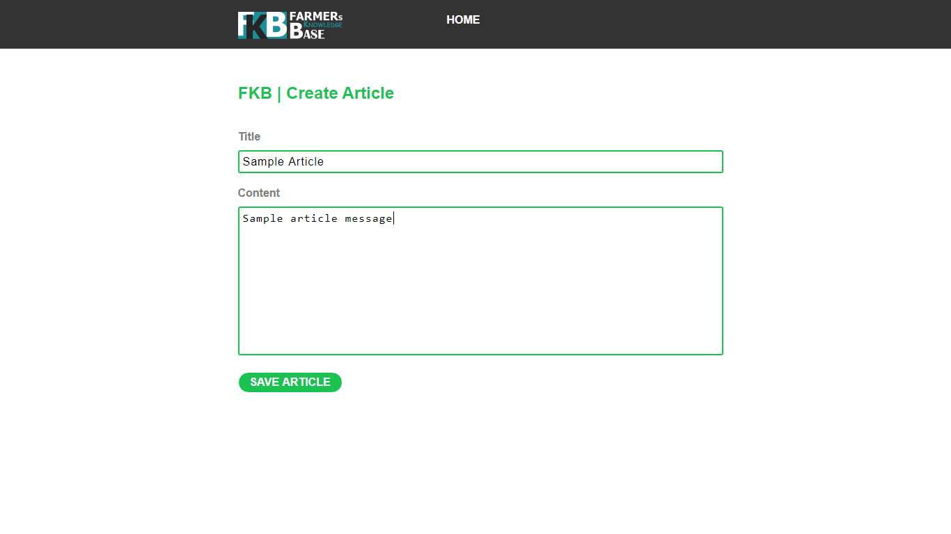

Fig8. Create an article page

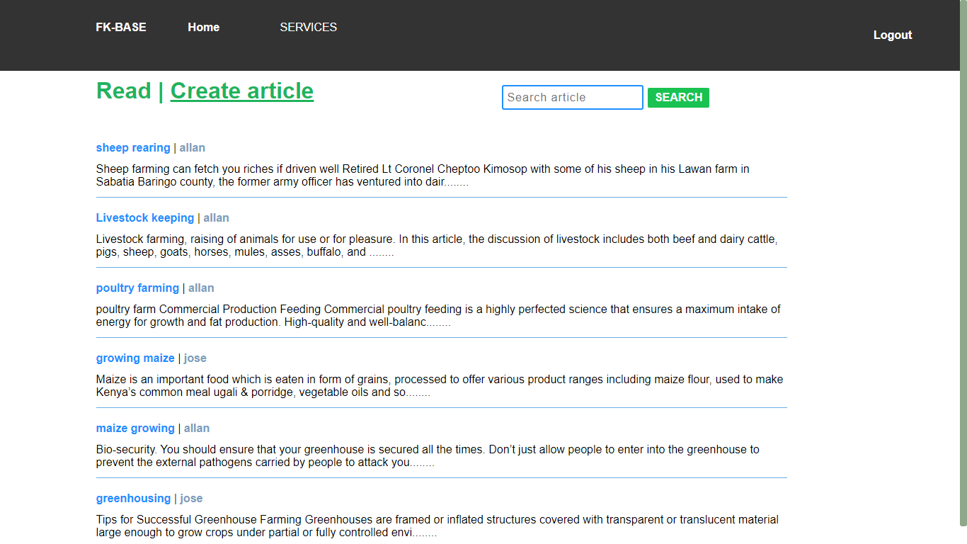

Fig9. Articles and learning materials page

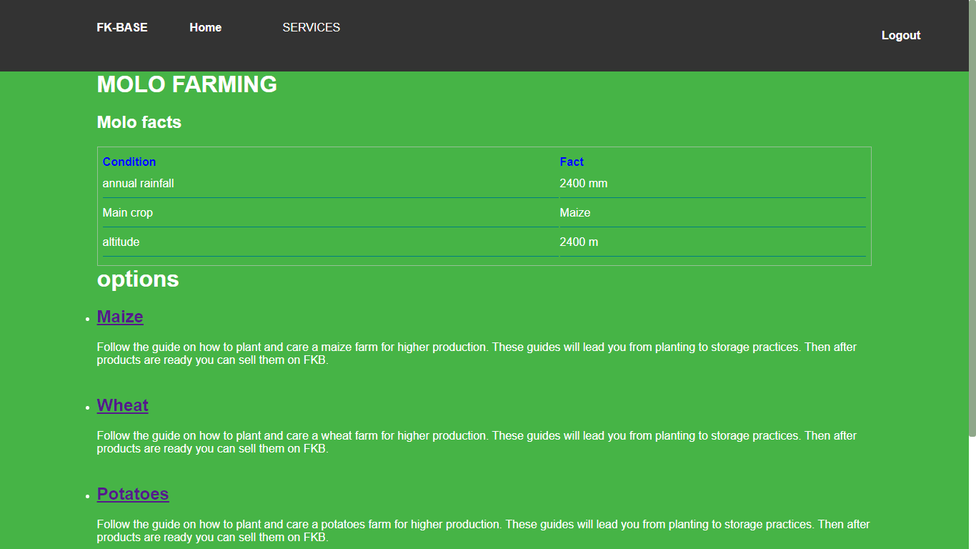

Fig11. Region fact and suggestion.

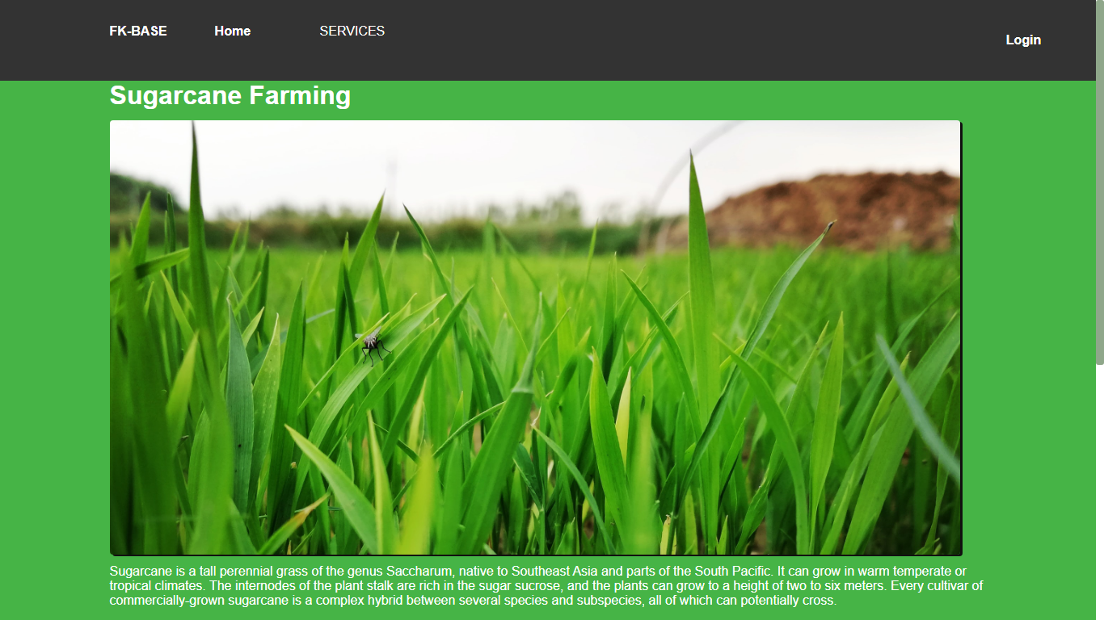

Fig12. Crop page

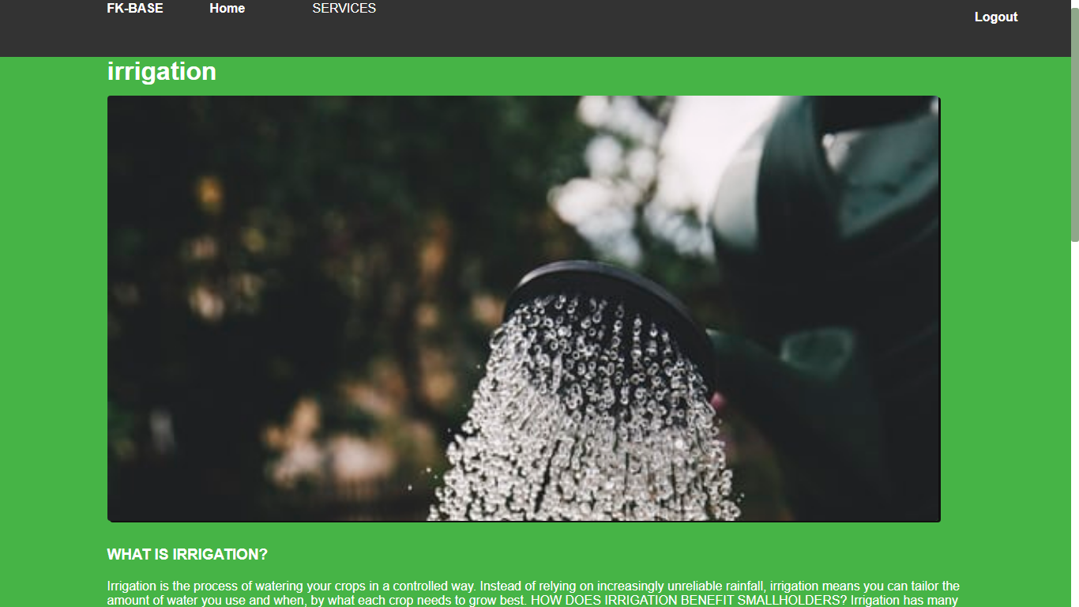

Fig13. Irrigation page

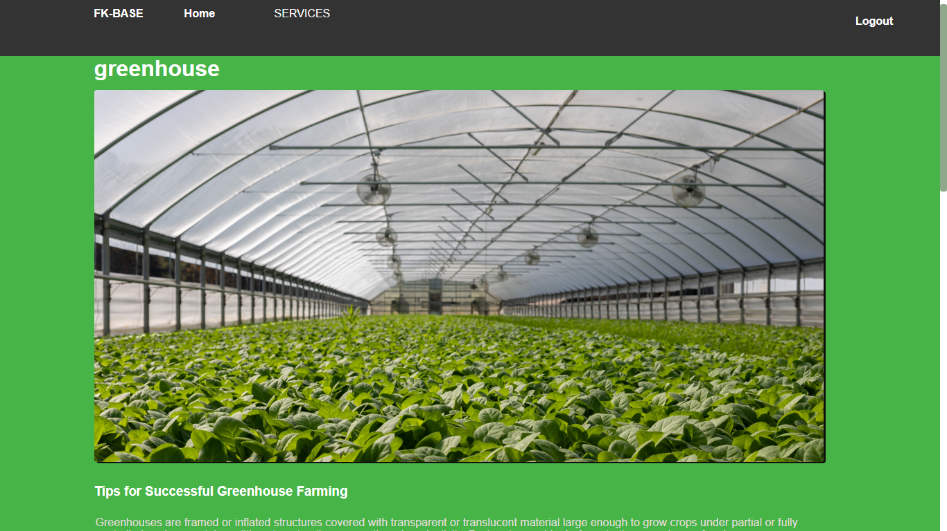

Fig13. Greenhouse page

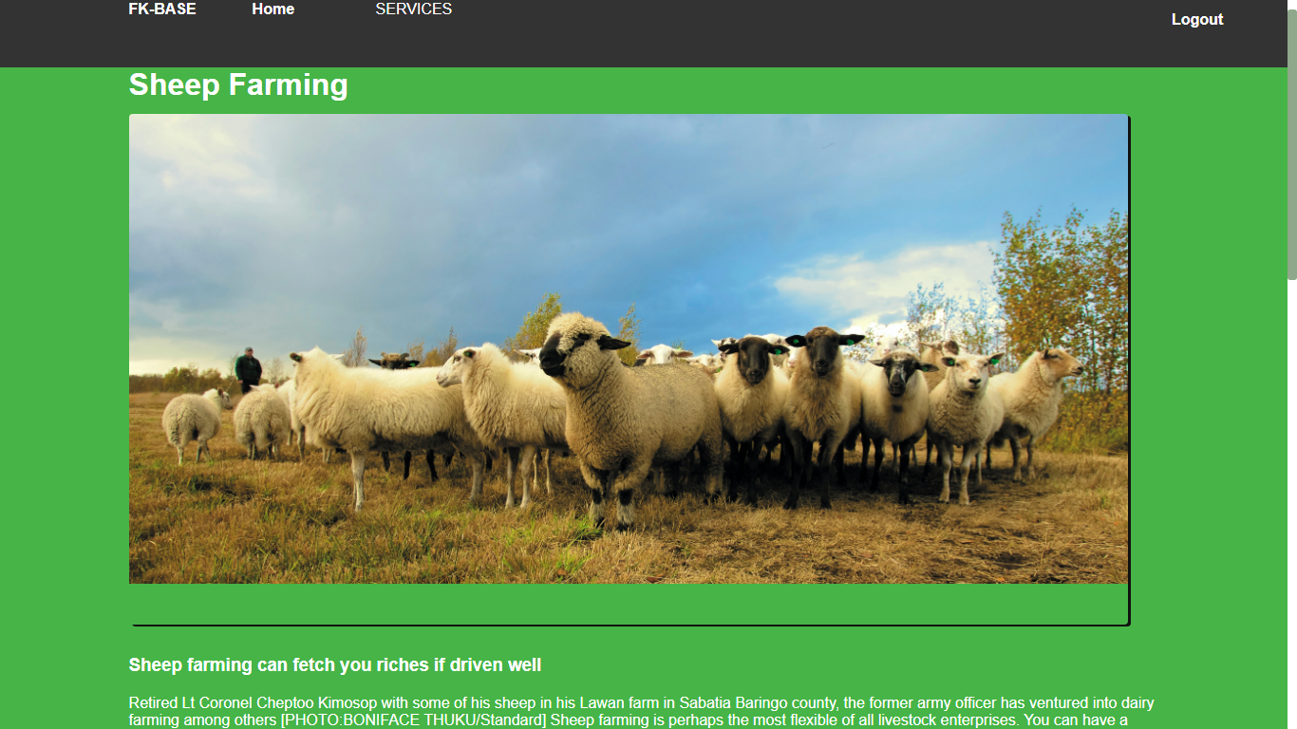

Fig14. Livestock keeping page

**CHAPTER FIVE**

**5.1 Conclusion**

The challenges to performance of the agricultural sector are numerous and so are the dimensions of addressing them. While government and development stakeholders have taken necessary actions in a number of critical areas, there seems to be no progress because other innovative interventions have not been tried. From the presentations in this paper, it has emerged that information technology plays a central role in propelling growth in the agricultural sector by supporting three cardinal areas: extension services, data management and decision support, and production and marketing. Focusing on these areas promises more effective interventions that could balance agricultural production per capita with population growth. In particular, Farmers Knowledge Base supports the following:

a. Decision making functionality to aid various farmers with decision-making.

b. Advice to farmers on agricultural best practices using an up-to-date agricultural knowledgebase.

c. Production and marketing of crops through provision of improved seeds during planting season and offering best prices for harvested crops.

In terms of future work, the advisory sub-system should be extended with document enrichment

capability whereby, search results are returned as one enriched file comprising of merged sections from different documents in the knowledgebase corresponding with the search keywords.

**5.2 RECOMMENDATION**

We would like to recommend to farmers to use this Farming Knowledge- based system to acquire more knowledge on various skills farming of farming to increase their produce and also Share their expertise with other farmers in order to improve the agriculture sector in our country.

We also would like to urge our fellow Kenyans to support the farmers by sharing their knowledge and by buying the farmers produce since by doing so we are building our country.

**REFERENCES.**

**1.** GOOGLE

2. YOUTUBE

**APPENDICIES**

HTML-Hypertext Markup Language

CSS- Cascading style sheet

Php- hypertext pre-processor